Chapter 1
INTRODUCTION
Our project titled, as “Cosmetic Layer Designer for GIS” is basically a GIS based project. The system is developed to provide a solution to our client organization i.e. National Development Complex (NDC). This chapter will present introduction all about this project.

1.1 INTRODUCTION TO NDC
National Development Complex was created with an objective of developing an infrastructure for indigenous development and production of modern weapon systems. It has been the goal of NDC to deliver reliable and state-of-the art weapon systems and military hardware at competitive prices. The National Development Complex manufactures a variety of products, including Energetic Materials and Propellants like HTPB, AP, A1 Powder, HX752, MAPO, and Hydrazine etc, along with all types of air-burst and chemical fuses, Telemetry Systems and Radar Altimeters, Pyrotechnics and initiatory devices, Missile Systems and Power Sources. Since its creation, NDC has made progress in producing a variety of weapon systems.
- Missile Systems
- Launchers
- Area Denial Bomb PSD-1
- Fuel-Air Explosive Bomb FAE-1
- Warheads For Anti-Armour & Tactical Applications
- Energetic Materials & Propellants
- Military Fuses
- Power Sources
- Defense-Electronics
Other work includes telemetry systems, radar altimeters, warhead controllers, safety & arming systems, and fuses, as well as production of various types of detonators, pyrotechnics, and initiatory devices is also underway.
Most of the research designing and analysis work is carried out at the NDC research centers. Modern computational facilities are maintained at these centers with state-of-the-art analytic and computational software for design conceptualization, virtual prototyping, analysis, and performance optimization. These centers are carrying out work in areas as diverse as aerodynamics, structures, flight dynamics & controls, guidance & navigation, simulations, propulsion and detonics.

1.2 INTRODUCTION TO TECHNOLOGIES USED
The Technology on which our project is based upon is GIS (Geographical Information Systems). Our target area is GIS by ESRI (Environmental Systems Research Institute).
    - Introduction to GIS
A Geographical Information System is a combination of skilled persons, spatial and descriptive data, analytical methods, and computer software and hardware- all organized to automate, manage and deliver information through geographic presentation.
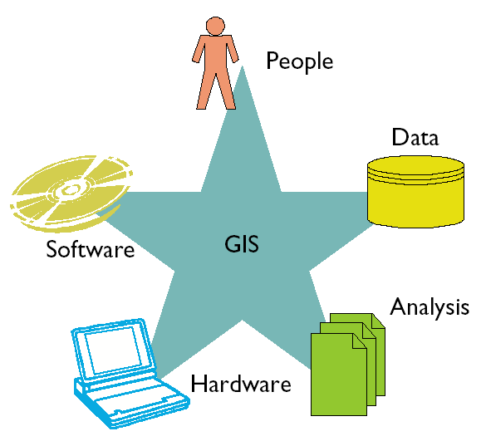

    - Introduction to ESRI
ESRI was founded as Environmental Systems Research Institute in 1969 as a privately held consulting firm that specialized in land use analysis projects. Originally located in a historical home among orange groves, the worldwide headquarters of ESRI are now anchored in a multicampus environment in Redlands, California.
The early mission of ESRI focused on the principles of organizing and analyzing geographic information. The firm carefully managed project work to ensure growth without the need for venture capital or going public. ESRI projects included developing plans for rebuilding the City of Baltimore, Maryland, and assisting Mobil Oil in selecting a site for the new town of Reston, Virginia. From these early projects emerged concepts for processes and tools that could be applied in an automated environment.
During the 1980s ESRI devoted its resources to developing and applying a core set of application tools that could be applied in a computer environment to create a geographic information system. This is what is known today as geographic information system (GIS) technology.
In 1981 ESRI launched its first commercial GIS software called ARC/INFO. It combined computer display geographic features, such as points, lines, and polygons, with a database management tool for assigning attributes to these features. Originally designed to run on minicomputers, ARC/INFO offered the first modern GIS. As the technology shifted to UNIX and later to the Windows operating systems, ESRI evolved software tools that took advantage of these new platforms. This shift enabled users of ESRI software to apply the principles of distributed processing and data management.
1981 was also the year ESRI held its first user conference. This conference, attended by 18 people at the ESRI office in Redlands, has now grown to the largest annual GIS event in the world, with more than 11,000 attendees from 90 countries.
ESRI evolved from a small consulting firm to the largest research and development organization dedicated to GIS by focusing on its user community. The relationship between ESRI and its users is synergistic. Over the years a unique culture has evolved, a culture that is user-focused and which emphasizes a team-based approach.
In 1986 another milestone was achieved with PC ARC/INFO, a stand-alone PC-based GIS station. This changed ESRI from a one-product company and opened the doors to even more innovative product development.
The 1990s brought more change and evolution. The global presence of ESRI grew with the release of ArcView, an affordable, easy-to-learn desktop mapping tool, which shipped an unprecedented 10,000 copies in the first six months of 1992. The company also launched the ArcData Program designed to promote the publishing of commercial off-the-shelf high-quality data sets to help users quickly build and grow their GIS applications. Today, that program has evolved into the Geography Network, a collaborative, multiparticipant system for publishing, sharing, and using geographic information on the Internet. ArcCAD software, also released in 1992, made GIS tools available in the CAD environment.
In 1994 ESRI addressed the needs of the business-to-business market with ArcSDE, which allowed the storage of spatial and tabular data in commercial DBMS products. The business-to-consumer market became part of the ESRI family with BusinessMAP and its related family of products.
ESRI's product line grew again in the mid-1990s with the release of ArcInfo for Windows NT, MapObjects (mapping and GIS components for software developers), the Data Automation Kit, and the acquisition of Atlas GIS. This expansion of ESRI's product family gave users a comprehensive set of GIS and mapping software options and fortified ESRI's position as the world leader in the GIS market.
In 1997 ESRI embarked on an ambitious research project to reengineer all of its GIS software as a series of COM objects. Several hundred man-years of development later, ArcInfo 8 was released in December 1999. ESRI also introduced ArcIMS, the only GIS software to enable users to integrate local data with Internet data in a simple browser interface.
In April 2001 ESRI began shipping ArcGIS 8.1, a family of software products that form a complete GIS built on industry standards that provide exceptional, yet easy-to-use capabilities right out of the box. ArcGIS is a scalable system for geographic data creation, management, integration, analysis, and dissemination for every organization, from an individual to a globally distributed network of people.
Today, ESRI GIS products are poised for even greater growth. Innovations in computer technology allow sophisticated GIS operations to be performed in the field on a personal digital assistant (PDA), on desktops, and throughout the enterprise. Faster and cheaper computers, network processing, electronic data publishing, and easier-to-use tools are fueling rapid growth in the desktop arena. Private businesses are adopting GIS technology as a decision support tool. And with the introduction of live mapping applications to the Web, anyone with a computer has access to the benefits of GIS technology.
Today, ESRI employs more than 2,700 staff, more than 1,400 of whom are based in Redlands, California, at the world headquarters. ESRI offers employment opportunities to qualified professionals from around the world and has a richly diverse work force. The Redlands campus has expanded with the addition of a new three-story Research and Development (R&D) Center, which opened in early 1996. Further expansion of the R&D Center was completed in the summer of 1998, and another state-of-the-art facility opened in summer 2001. With 11 regional offices in the United States, more than 75 international distributors, and users in more than 220 countries, ESRI stands ready to meet the needs of its user community and to set the standards for the GIS industry.
ESRI is privately held, debt-free, and there are no plans for the company to go public or change ownership. The company's focus remains on producing excellent software and delivering exceptional service to users. We at ESRI believe that better information makes for better decisions. Our reputation is built on contributing our technical knowledge, our special people, and valuable experience to the collection, analysis, and communication of geographic information."
    - Introduction to GIS by ESRI
Since 1969, ESRI has been helping professionals and managers solve geographic problems. A pioneer in geoprocessing tools, ESRI is wholly dedicated to geographic information system (GIS) and geoprocessing technology. ESRI's ARC/INFO® software was the first database-oriented GIS to be developed in the world. Its introduction started a revolution in computer mapping and the way professionals manage spatial information. Today, more than 100,000 organizations around the world use ESRI® software because it encompasses the leading ideas in technology for geographic information management.
    - Introduction to Shapefile
A shapefile is a standard file format by ESRI and this is one of the main building blocks of our project. A shapefile stores nontopological geometry and attribute information for the spatial features in a data set. The geometry for a feature is stored as a shape comprising a set of vector coordinates.
Because shapefiles do not have the processing overhead of a topological data structure, they have advantages over other data sources such as faster drawing speed and edit ability. Shapefiles handle single features that overlap or that are noncontiguous. They also typically require less disk space and are easier to read and write.
Shapefiles can support point, line, and area features. Area features are represented as closed loop, double-digitized polygons. Attributes are held in a dBASE® format file. Each attribute record has a one-to-one relationship with the associated shape record.
The technical specification of a shapefile is that an ESRI shapefile consists of a main file, an index file, and a dBASE table. The main file is a direct access, variable-record-length file in which each record describes a shape with a list of its vertices. In the index file, each record contains the offset of the corresponding main file record from the beginning of the main file. The dBASE table contains feature attributes with one record per feature. The one-to-one relationship between geometry and attributes is based on record number. Attribute records in the dBASE file must be in the same order as records in the main file.

Examples:
Main file: counties.shp
Index file: counties.shx
dBASE table: counties.dbf
The main file (.shp) contains a fixed-length file header followed by variable-length records. Each variable-length record is made up of a fixed-length record header followed by variable-length record contents. Figure 1 illustrates the main file organization.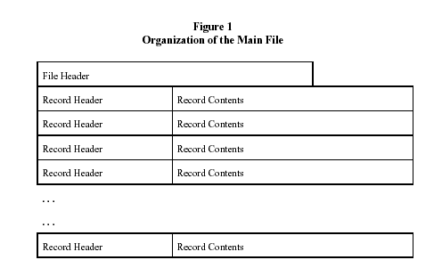
Byte Order: All the contents in a shapefile can be divided into two categories:
- Data related
· Main file record contents
· Main file header’s data description fields (Shape Type, Bounding
Box, etc.)
- File management related
· File and record lengths
· Record offsets, and so on
The integers and double-precision integers that make up the data description fields in the file header (identified below) and record contents in the main file are in little endian (PC or Intel®) byte order. The integers and double-precision floating point numbers that make up the rest of the file and file management are in big endian (Sun® or Motorola®) byte order.
The Main File Header: The main file header is 100 bytes long. Table 1 shows the fields in the file header with their byte position, value, type, and byte order. In the table, position is with respect to the start of the file.
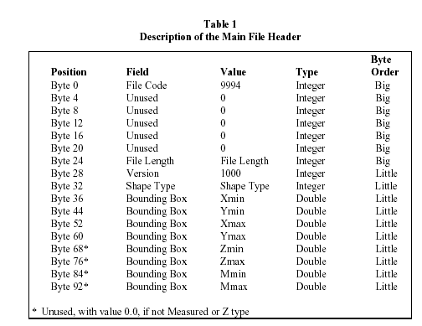
The value for file length is the total length of the file in 16-bit words (including the fifty 16-bit words that make up the header).
All the non-Null shapes in a shapefile are required to be of the same shape type. The values for shape type are as follows:
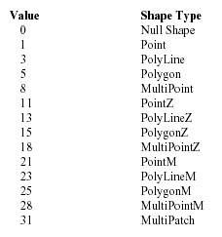
Shape types not specified above (2, 4, 6, etc., and up to 33) are reserved for future use. Currently, shapefiles are restricted to contain the same type of shape as specified above. In the future, shapefiles may be allowed to contain more than one shape type. If mixed shape types are implemented, the shape type field in the header will flag the file as such.
The Bounding Box in the main file header stores the actual extent of the shapes in the file: the minimum bounding rectangle orthogonal to the X and Y (and potentially the M and Z) axes that contains all shapes. If the shapefile is empty (that is, has no records), the values for Xmin, Ymin, Xmax, and Ymax are unspecified. Mmin and Mmax can contain "no data" values for shapefiles of measured shape types that contain no measures.

INTRODUCTION TO TOOLS USED
    - C++
An industry standard object-oriented compiled language, formally standardized in 1998, but tracing its history to the early 1980s, with a heritage in C and Simula. C++ is a general-purpose programming language with a bias towards systems programming. C++ runs on most computers from the most powerful supercomputers to the ubiquitous personal computers. Symbian OS is written in C++.

    - Qt
Qt is a complete C++ application development framework. It includes a class library and tools for cross-platform development and internationalization. One of the key design goals behind Qt is to make application programming intuitive, easy and fun. Qt achieves this goal by abstracting low-level infrastructure functionality in the underlying window and operating systems, providing a coherent and logical interface that makes sense to programmers.
The Qt API and tools are consistent across all supported platforms (see below for details), enabling platform independent application development and deployment. Qt applications run natively, compiled from the same source code, on all supported platforms:
Qt/Windows (MS Windows 95/98/Me, NT4, 2000 and XP)
Qt/X11 (Linux, Solaris, HP-UX, IRIX, AIX, many other Unix variants)
Qt/Mac (Mac OS X)
Qt/Embedded (embedded Linux)

1.3.2.1 Qt Components
Qt consists of several components: The Qt library, applications for GUI design, internationalization and documentation/help file reading, and finally cross-platform build and utility tools.

1.3.2.2 The Qt Class Library
The Qt Class library is the main component of Qt. The library makes available approximately 400 classes with most of the infrastructure functionality needed to build nontrivial applications. It contains classes for GUI, tools, networking, database handling, XML, and much more.

1.3.2.3 GUI Design
Qt Designer is a full-fledged GUI builder. Using Qt Designer, application designers can layout and preview the GUI of their applications.

1.3.2.4 Internationalization
Applications for international markets need to cater to multiple languages and writing systems. Qt supports global applications out of the box, and adds a set of tools designed to make the internationalization workflow smooth.

1.3.2.5 Documentation and Help
Most complex applications need online documentation and help. Qt addresses this need by including Qt Assistant - a configurable, redistributable help file / documentation reader. Qt Assistant can easily be customized and redistributed with your Qt application.

1.3.2.6 Cross-Platform Builds
Writing software for multiple platforms can be tedious and error-prone. Maintaining makefiles can be even more so, especially if several makefiles are required for different compiler and platform combinations. Qt addresses this challenge by including the qmake tool, which takes care of generating correct makefiles for the target platforms.

1.3.2.7 Business benefits

Expanded Markets
You can use a surprisingly small amount of resources to realistically target Windows, Linux/Unix, Mac OS X, and embedded Linux platforms.

Short Learning Curves
Qt developers only have to learn one API to write apps that run almost anywhere.

Lower Maintenance
By eliminating the need for multiple source-trees, Qt eliminates the evils (and costs) of maintaining and administering them.

More functionality, less work
Qt lets you concentrate on value-adding innovation, instead of worrying about maintaining and administering infrastructure and interfaces for multiple versions of existing applications.

1.4 PROJECT OVERVIEW
Cosmetic Layer Designer for GIS can be used on multiple platforms without any additional requirements. The beauty of this designer is user-friendly environment and capability of a user to draw data layers of his interest. It deals with digitized map format known as Shapefile, which is described in section 1.2.4. The specialty of our software, that distinguishes it with others, is the introduction of Cosmetic (customized) layers and its efficiency of displaying maps.
Cosmetic Layer Designer for GIS is a software application that will enable the user to draw multiple layers on the digitized map, which are geo-referenced. A layer may represent a chain of hospitals or multiple locations of an office across the globe or in a single country. A user will be able to draw layer of his own choice and on demand, he can place that custom layer back onto the map to see his provided information. In this way, at a time a user can place all the layers on to a single map to get as per his requirements (for example, a user can place a layer of hospitals in Pakistan as well as a layer containing the public exchange locations across the country).
The main operations that the software will perform are:
- Read a digitized map.
- Display it in efficient manner. By efficient manner, we mean displaying the map using multi-threaded process.
- Implement the zooming, panning and projection operations on the map.
- Enable the user to turn ON or OFF the visibility of a particular layer onto the map.
- Allow the user to create a cosmetic layer, which can enables the user to draw shapes.
Our project is not limited to NDC. It is very similar to other software already in the market, like Microsoft MapPoint, MapInfo and ESRI ArcView. These software are targeting different kind of users.

1.5 PROJECT MODULES

1.5.1 MapLayer Module
- Adds a map layer.
  - This module opens a Shapefile (a standard File format of ESRI) in SmartMap software.
  - Read all the shape records.
  - Creates shape objects.
  - Adds them to QPtrList of MapLayer.
  - Appends this map layer to QptrList of layers.
- Remove a Map Layer.
- Moving up/down a layer in the layers’ stack.
- Hide/unhide a layer.

Project File Module
- This module opens a project file.
- This module saves/creates a project file.
- This module closes a project file.

Map Display Module
- Lat/Long to pixel conversions.
- Pixel to Lat/Long conversion.
- Display map.
- Zoom in a map.
- Zoom out a map.
- Zoom to Full Extent a map.
- Pan a map.

Cosmetic Layer Module
- Creates a Cosmetic Layer.
- Writes Cosmetic Layer Objects into the shapefile.
- Places an object on Cosmetic Layer.
- Drags/Resizes objects on the Cosmetic Layer.
- Deletes an object on Cosmetic Layer.
- Cuts an object in Cosmetic layer.
- Copies an object in Cosmetic layer.
- Pastes an object in Cosmetic layer.

Chapter 2
LITERATURE REVIEW
Suggested sources of articles/book-chapters are:
- ESRI GIS. Modeling our World. The information contained in this document is the exclusive property of Environmental Systems Research Institute, Inc. This work is protected under United States copyright law and other international copyright treaties and conventions. No part of this work may be reproduced or transmitted in any form or by any means, electronic or mechanical, including photocopying and recording, or by any information storage or retrieval system, except as expressly permitted in writing by Environmental Systems Research Institute, Inc. All requests should be sent to Attention: Contracts Manager, Environmental Systems Research Institute, Inc., 380 New York Street, Redlands, CA 92373-8100, USA.
- ESRI GIS. Geocoding Tutorial. This tutorial introduces you to geocoding with ESRI ® ArcGIS 8.1. It will show you the basic techniques for creating geocoding services and performing address geocoding with ArcGIS. Complete exercises 2 and 3 to learn about some advanced features using alternate names and place name aliases and creating a dynamic feature class that is related to the address table. This tutorial assumes that you are already familiar with using ArcCatalog and ArcMap. You should know how to copy data to a new location and add data to a map. You should also have a basic understanding about what a geodatabase is and the objects they can contain. If you are new to GIS or feel you need to refresh your knowledge, please take some time to read Getting Started with ArcGIS. You might also work though the quick-start tutorials in Using ArcCatalog and Using ArcMap.
- ESRI GIS. Understanding Map Projections. The information contained in this document is the exclusive property of Environmental Systems Research Institute, Inc. This work is protected under United States copyright law and other international copyright treaties and conventions. No part of this work may be reproduced or transmitted in any form or by any means, electronic or mechanical, including photocopying and recording, or by any information storage or retrieval system, except as expressly permitted in writing by Environmental Systems Research Institute, Inc. All requests should be sent to Attention: Contracts Manager, Environmental Systems Research Institute, Inc., 380 New York Street, Redlands, CA 92373-8100, USA.
- ESRI Using ArcExplorer Java. The information contained in this document is the exclusive property of Environmental Systems Research Institute, Inc. This work is protected under United States copyright law and other international copyright treaties and conventions. No part of this work may be reproduced or transmitted in any form or by any means, electronic or mechanical, including photocopying and recording, or by any information storage or retrieval system, except as expressly permitted in writing by Environmental Systems Research Institute, Inc. All requests should be sent to Attention: Contracts Manager, Environmental Systems Research Institute, Inc., 380 New York Street, Redlands, CA 92373-8100, USA.
- ESRI Shapefile Technical Description. The information contained in this document is the exclusive property of Environmental Systems Research Institute, Inc. This work is protected under United States copyright law and other international copyright treaties and conventions. No part of this work may be reproduced or transmitted in any form or by any means, electronic or mechanical, including photocopying and recording, or by any information storage or retrieval system, except as expressly permitted in writing by Environmental Systems Research Institute, Inc. All requests should be sent to Attention: Contracts Manager, Environmental Systems Research Institute, Inc., 380 New York Street, Redlands, CA 92373-8100, USA.
Other literature reviews collected are:
- ArcPad software from Environmental Research Systems, Inc. (ESRI) runs on Windows CE and is one of the most widely available software packages for mobile GIS and data capture. ArcPad can operate in wireless or snapshot infrastructures, provides integration with GPS units, and navigation, query, and map display capabilities. ArcPad Application Builder can be used to develop forms, toolbars, applets, extensions, and scripting for manipulating spatial and attribute data (ESRI 2002, Zhong-Ren and Ming-Hsiang, 2003).
- DeSanty, Flock and Applegate, (2001): A third case study describes a method for using GIS software to assign random locations for sampling points within irregularly shaped habitat polygons. The study did not use a mobile data collection system but rather obtained coordinates for sampling locations using tools in ESRI’s ArcView software. The coordinates were then located in the field using a handheld GPS receiver. The authors failed to describe how the parameters for number of points, distance between points, and distance from edge were selected, the type of GPS unit used, and whether the coordinates were imported into GPS unit for navigating or simply referred to while using the GPS unit to periodically check positions. This paper does little to inform the NRDT project except to point out the availability of an automated tool for randomly selecting sampling points.
- Blanchette & Summerfield (2003). Qt is a cross platform widget library for rapid application development by Trolltech. It's a well developed and mature library used in a wide number of applications and has had quite a few books written for it. The SAMS "Qt in 24 hours" book springs to mind. Most of them are fairly okay. None really do very much to teach the library. This one stands out. It starts with the ubiquitous "Hello Qt" application and then (rather quickly) goes on to explain the SLOT/SIGNAL communication system between the widget and the program (effectively, it is the event handling machinery, but in an easy to understand way). Besides the core libraries, the book also has a reasonable introduction to using the Qt designer. Those use to the Microsoft Visual Studio forms interface will be right at home with Qt's designer as it is very similar. My only bind with the book is simple. Not all of the code example as they are will compile on my machines; the vast majority does. The attention to detail, the simple explanations to some very complex classes is refreshing and the whole approach makes this the book to buy if you're serious about using Qt.
- Maidment (1993) provided an intellectual basis for linkage between GIS and hydrologic modeling: a scope within which GIS could be employed for determining parameters for lumped surface hydrologic models, groundwater flow, storm water pollutant and sediment transport, and urban storm drain systems. Additionally, he indicates the potential for development of new spatial hydrologic models, the use of which would not be contemplated without GIS capability. Of specific relevance to this thesis is Maidment’s recommendation for development of a new look-up table for using land use types classified by the Anderson system to establish runoff curve numbers for the US Department of Agriculture Soil Conservation Service hydrologic methods. This project provides such tables using existing Anderson Level II codes and by developing new, more detailed level codes that are related to runoff curve numbers based on hydrologic soil groups.
- ESRI's recent switch to the geodatabase data model in the ArcGIS software suite has prompted I&M to investigate the possibility of developing the NRDT as a geodatabase. Geodatabases are Microsoft Jet engine databases (.mdb files), so the potential exists to develop the NRDT as a geodatabase with a Microsoft Access user interface. This would simplify data management because spatial and attribute data would be stored in one database container that could be loaded on a mobile device and updated in the field. The advantage to the Access interface would be the enforcement of referential integrity and data quality rules when entering and updating attribute data. Compas (2003) found that it would be possible to convert an I&M database into a geodatabase, however learning how to manipulate and modify geodatabases is not a simple undertaking and making changes with an Access user interface can corrupt geodatabases.
- Johnson (1990) found GIS to be a useful tool in natural resource studies because of its ability to perform analysis of spatial overlay. The process of spatial overlay is simply the layering of two maps so that data can be analyzed. For instance, the distance between two geographic features from one another can be calculated using GIS.
- Lovett, Brainard, and Bateman (1997) used GIS to develop a model to predict the number of visitors to a recreation site in England. They concluded that GIS significantly improved the calculation of distances for the recreation demand model. This report is the first to use GIS to determine marketability of pay pond businesses based on spatially referenced data, as well as the first to utilize a shapefile of pay pond businesses in West Virginia.
- Donovan and Fletcher (1999) studied mine flooding in the Pittsburgh coal using GIS, collecting water level data, and analyzing ground water flow and the behavior of flow through mines. Coal left intact in and around the mine can act as a less permeable barrier if the hydraulic conductance is low, where the size of the coal block determines the conductance. Mapping of coal pillars and barriers is needed to interpret the underground flow system. Multiple GIS coverages displayed the hydraulic head of the water in abandoned mines at several dates showing the rising or falling hydraulic head of the area. GIS enabled difficult hydrologic and geochemical aspects to be visualized; however, the study did not perform analysis of data with GIS tools, so it only used GIS to store and display data.
- In order to ensure a comprehensive and effective Geographic Information System, research was conducted on various aspects of the facility siting phenomena. Journal articles, government publications, books, and websites were examined to obtain past and present knowledge on siting practices (Baban and Parry, 2001; Rogers, 1998; Ibitayo and Pijawkw, 1999; Brazier and Greenwood, 1998; Minehart and Neeman, 2002). This knowledge provides a strong foundation for the rest of the project, and the knowledge gained will also act as a framework for our analysis. Specific factors and constraints (criteria) will be derived from this framework.
- White and Hofschen (1993) developed a spatial model for assessing nutrient loads in New Jersey rivers using Arc/Info. They used 3 arc-sec digital elevation models (DEM) to partition the study area (15,385 km²) into 2,893 drainage basins (polygons) with a network of 10,916 stream segments (arcs). Time of travel was assumed as the basis for calculating predictors of water quality. The simple formula v = 0.38 * Q 0.24, which was estimated for New Jersey, was used to estimate the flow velocity in each reach. A first-order decay reaction was assumed to calculate the non-conservative downstream transport. White and Hofschen attempted to improve the model by representing the decay constant as a function of stream slope, and the nonpoint source yields as a function of subbasin gradient. The nitrogen model performance showed no improvement with these refinements. White and Hofschen found that the time of travel, which was calculated from the exponential velocity formula, underestimated by a factor of 0.57 the time of travel of dye-tracer, that is, the dye took approximately twice as long to traverse the stream as the formula suggested. This travel time underestimation was accommodated by assignment of higher values of pollutant decay than those reported in the literature.
- Mueller et al. (1993) applied logistic regression to relate discrete categories of nitrate concentrations to such explanatory variables as land use in the drainage basins upstream from the sampling sites, percentile of stream flow at the time of sampling, acreage of the basin in corn, acreage in soybeans, density of cattle, and population density. They extracted data from GIS databases stored in 1:2,000,000- scale maps of the conterminous United States. The GIS software was used only to a really weight the extracted data and sum it by basin; their model did not include stream transport. Better classification of nitrate concentration was achieved by model that included the flow percentile; the areal extend of corn and soybean production, the density of cattle, and the density of population, then the model that contained percentile of flow, nitrogen fertilizer application, and population density. In addition, Mueller et al. found, that as the percentile of flow increased, the probability of nitrate concentration being in a higher category also increased. Low explanatory power of fertilizer application researchers explained by the fact, that the fertilizer use was approximated by the county level sales thus such nitrate sources as manure were not included.
- Ragan (1991) developed a personal computer-based GIS named GIS-HYDRO. This allows a user to assemble predetermined land use, soil and slope data clipped within a user-defined boundary. A digitizer is used to delineate the watershed boundary, flow paths, and define land use changes. GIS-HYDRO provides basic file setup for use in the computer program TR 20 (1986).
- Miller et al (2002) : Project Battuta is one system under development that seeks to provide field workers that have limited training in GIS and other computer information systems with access to wireless data collection technology. The Project Battuta infrastructure relies on wrappers at the mobile device and data source to standardize heterogeneous elements in each environment. A mediator is then used to transmit information requests between the mobile device and the data source. (Note: the author did not define the terms “wrapper” and “mediator”. I attempted to contact the author for clarification, but received no reply). The Project Battuta infrastructure model appears to be a robust solution to the problem of heterogeneity within a mobile computing environment. However, it is unlikely that the majority of natural resources field personnel in I&M have the time or ability to easily develop and implement such a system at this time.

Chapter 3
ANALYSIS

3.1 SCOPE OF THE PROPOSED SYSTEM
The proposed system i.e. Cosmetic Layer Designer for GIS is a GIS based application and deals with a digitized map format known as Shapefile. This format is used by ESRI for GIS based applications and is the best format for vector graphics based maps. The specialty of this software, that distinguishes it with others, is the introduction of Cosmetic layers and its efficiency of displaying maps. A Cosmetic layer is a layer that a user can customize according to the spatial user’s needs.
The project is not limited to NDC. It is very similar to other software already in the market, like Microsoft MapPoint, MapInfo and ESRI ArcView. These software are targeting different kind of users.
The functional area of this application that lies under the scope of proposed system is the addition, removal, and display of shapefiles. Another functionality covered by the project is zooming of digitized maps, that is zooming in or out or to its full extent, and also the panning operation that is dragging a map to a specific location on map.
  - PROJECT OBJECTIVES
The objectives of the project describe that what is to be ultimately achieved from the development of the project. It is always essential and helpful to understand all the objectives and the requirements that the computer based system is expected to satisfy in addition, the relative importance of each objective should also be understood.
Our software application has some objectives that are the requirements of our client organization. The core functions that SmartMap application supports are:
- Read a digitized map.
- Display it in efficient manner. By efficient manner, we mean displaying the map using double buffering technique.
- Implement the zooming, panning and projection operations on the map.
- Enable the user to turn ON or OFF the visibility of a particular layer onto the map.
- Allow the user to create a cosmetic layer, which can enable the user to draw shapes.
The proposed system is also required to fulfill the following objectives along with its core objectives.
- To assure the availability of the right information at the right time.
- To make the information storage, processing and retrieval efficient.
- To provide a system with a user-friendly interface which is simple to understand and efficient to use.
- To provide a system which can be easily modified for the future enhancements.
3.3 MAIN FEATURES OF THE PROPOSED SYSTEM
The proposed system has the following main features.
3.3.1 Efficiency
Efficiency of the system is concerned with the minimum processing time as well as the optimal use of system resources in designing the proposed system; the efficiency factor has been taken well into consideration.
Efficiency of SmartMap application has bee checked and is:
Sr. No. | Size of Shapefile | Software | Machine | Time
1. | 3.2 MB | Map Info. | Pentium IV | 6 Seconds
 | 3.2 MB | Our Proposed System | Pentium IV | 2 Seconds
2. | 7.17 MB | Map Info. | Pentium 2.8 GHz with 512 MB RAM | 120 Seconds
 | 7.17 MB | Our Proposed System | Pentium 2.8 GHz with 512 MB RAM | 4 Seconds

3.3.2 User Friendly Interface
The interface of the system will be user friendly. The information retrieval, insertion, editing, and deletion of objects on map layers will be made easy and simple, so that a common user can handle the database efficiently.
3.4 FEASIBILITY STUDY
The main purpose of feasibility study is to consider the proposed system with a view to decide whether the development of the proposed system is feasible for the organization in the underlying circumstances. It is considered that whether the proposed system will meet all the requirements of the organization with improved efficiency than the existing software.
The feasibility of the system is considered from the following three aspects.

- Financial feasibility
- Technical feasibility
- Operational feasibility
3.4.1 Financial Feasibility
Since the system is being developed as a MCS Degree requirement project, so no development expenditures will be charged for the whole development and the system will be free to use for the NDC organization. The tools being used for the development are C++, an object oriented Language and cross platform library Qt makes it possible to run the system on multiple operating systems. For Qt, the organization has to purchase the license worth US $ 4990; the complete pricing list of Qt licenses is available at http://www.trolltech.com/products/qt/pricing.html. No other expensive development tools; Software or Hardware is used, so the project is very much feasible financially.
3.4.2 Technical Feasibility
As the organization is a well-reputed national institution with software business as well and they also provide consultancy services to some of the related national organizations, so full technical supervision will be available for the system. On the other hand, system does not have any extra ordinary technical requirement. So the project is technically feasible too.
3.4.3 Operational Feasibility
The proposed system will be operationally feasible because it will be efficient, accurate and reliable and will provide more facilities than other existing systems. The proposed system will be user friendly and easy to understand, so average person would be able to understand and use this system easily, no high computer knowledge would be required for it, but just some knowledge of GIS based systems is required.

3.5 REQUIRMENTS MODEL

The requirement model aims to delimit the system and define the functionality that the system should offer. For that reason this model provides a base for the rest of the development in OOSE. The requirement model consists of following parts:
Use-Case Diagram
Interaction Diagrams
3.5.1 Use Cases and System Boundary Diagram:

System Boundary Diagram
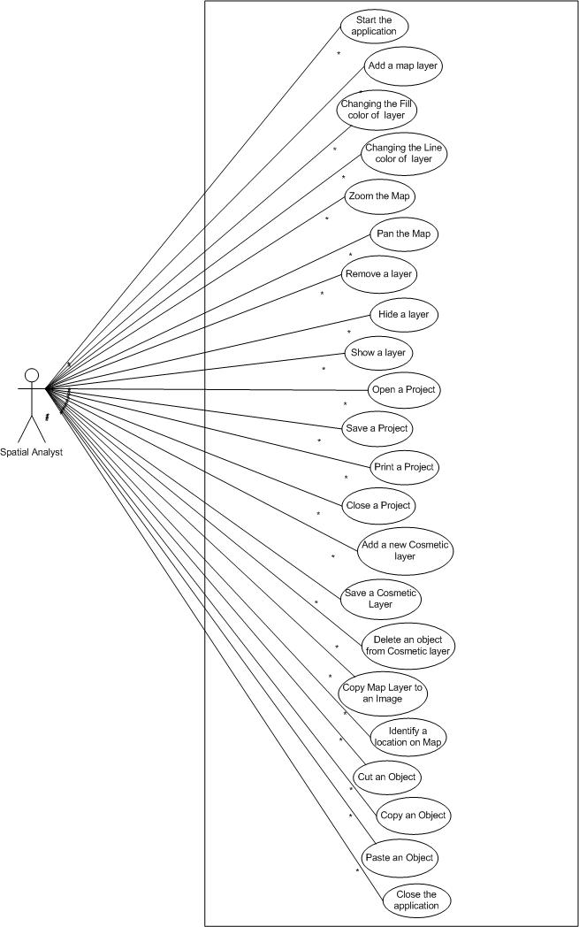

Use cases:
Start the Application:
Actors:
Spatial Analyst.
Pre Condition:
  - Operating System should be properly running.
  - SmartMap application is properly installed on the system.
Post Condition:
  - Started up the application with no errors.
  - All the application startup settings are properly loaded.
Description:
This describes about Starting/Opening of SmartMap application.
Close the Application:
Actors:
Spatial Analyst.
Pre Condition:
  - Application should be opened.
  - There may be some map layer opened into the map window.
Post Condition:
  - Closed application with no errors.
  - Any unsaved data is saved.
Description:
This describes about Closing of SmartMap application.
Add a map layer into the Map Window:
Actors:
Spatial Analyst.
Pre Condition:
  - A valid shapefile representing a map layer should be present.
Post Condition:
  - Displayed opened shapefile in a separate map layer in the map window.
  - A Map layer Name is displayed in the layer panel.
Description:
This describes opening process of a Shapefile (.shp) in SmartMap as a Map Layer.
Changing the Fill color of a layer:
Actors:
Spatial Analyst.
Pre Condition:
  - A shapefile representing a layer should be present.
  - A respective layer (whose color is to be changed) is selected to change its color related properties.

Post Condition:
  - Displayed opened shapefile in a separate map layer in the map window.
  - Different layers displayed in different colors.
Description:
This describes process of changing the color filled in the shapes in a Map layer, if there is not a good color that distinguishes it with other layers. Separate layers displayed in a same color can overlap one another, not making the sense clear; the Analyst needs distinguished separate layers by displaying them in different colors.
Changing the Line color of a layer:
Actors:
Spatial Analyst.
Pre Condition:
  - A shapefile representing a layer should be present.
  - A respective layer (whose color is to be changed) is selected to change its color related properties.
Post Condition:
  - Different layers displayed in different colors.
Description:
This describes process of changing the line color of the shapes in a Map layer, if there is not a good color that distinguishes it with other layers’ Line Color.

Zoom the Map to Full Extent:
Actors:
Spatial Analyst.
Pre Condition:
  - A valid shapefile representing a map layer should be present.
Post Condition:
  - Displayed opened shapefile in a separate map layer in the map window.
  - A Map layer Name is displayed in the layer panel.
Description:
There is a fixed scale factor at which the Map is zoomed to a level it can be displayed the whole in a single screen. This use case describes this level of zooming in SmartMap application.
Zoom In the Map:
Actors:
Spatial Analyst.
Pre Condition:
  - One or more layers are selected to be displayed in the map window.
Post Condition:
  - Displayed one or more opened layers at a required level of zoom in.
Description:
This use case describes the way the SmartMap handles Zoom In process of a map.
Zoom Out the Map:
Actors:
Spatial Analyst.
Pre Condition:
  - One or more layers are selected to be displayed in the map window.
Post Condition:
  - Displayed one or more opened layers at a required level of zoom out.
Description:
This use case describes the way the SmartMap handles Zoom Out process of a map.
Panning the Map:
Actors:
Spatial Analyst.
Pre Condition:
  - One or more layers are selected to be displayed in the map window.
Post Condition:
  - Display a location on the map where a user wanted to go on the screen.
Description:
This use case describes the way the SmartMap handles the Panning Operation of a map, i.e. To press the mouse button anywhere on the map to drag it to the desired location and release the mouse button; now the required map area is visible to you.

Remove a layer:
Actors:
Spatial Analyst.
Pre Condition:
  - One or more layers are selected to be displayed in the map window.
Post Condition:
  - Display a map after removing some layer from it that is now not shown in the map.
  - All the other opened/selected layers are shown in the map.
Description:
This use case describes the way of removing a layer (a Shapefile) in SmartMap Application. Infact, the application properly closes this opened Shapefile after which all the shapes in that closed layer are invisible in the map window.
Hide a layer:
Actors:
Spatial Analyst.
Pre Condition:
  - One or more layers are selected to be displayed in the map window.
Post Condition:
  - Display a map after removing some layer from it that is now not shown in the map.
  - All the other opened/selected layers are shown in the map.
Description:
This use case describes the way to hide a map layer. When a layer is deselected in the Legend window, the application does not remove but hides that layer in the map window. Afterward, the same layer can be selected in the legend window to be visible again in the map window.
Show a layer:
Actors:
Spatial Analyst.
Pre Condition:
  - Some or no layers are selected to be displayed in the map window.
Post Condition:
  - Display a map showing that layer also in the Map window along with other layers if there are any.
  - That layer’s checkbox is checked now as it can be viewed in the Map window.
Description:
This use case describes the way to show a map layer that is hidden before. When a layer is selected in the Legend window, the application shows that layer in the map window. Afterward, the same layer can be deselected in the legend window to hide it again in the map window.
Save a Project:
Actors:
Spatial Analyst.

Pre Condition:
  - One or more shapefiles are opened in the Map window.
Post Condition:
  - A saved project file containing different layers.
Description:
This use case describes the way to save more than one map layers in a logically combined in a single project file.
Open a Project:
Actors:
Spatial Analyst.
Pre Condition:
  - A valid project file with an extension .pro is selected to be opened.
Post Condition:
  - Different layers (shapefiles) are opened in the software instead of opening multiple shapefiles.
Description:
This use case describes the way to open a saved project. A project is a logical collection of one or more map layers/shapefiles.
Close a Project:
Actors:
Spatial Analyst.
Pre Condition:
  - A Project is opened in the software.
Post Condition:
  - A project file containing different layers is closed.
  - The Legend window is not showing any layer in it.
  - The Map window is not displaying layers anymore.
Description:
This use case describes the way to close a project. A project is a logical collection of one or more map layers/shapefiles.
Add a new Cosmetic layer in Map Window:
Actors:
Spatial Analyst.
Pre Condition:
  - The SmartMap Application should be opened.
Post Condition:
  - A cosmetic (custom) layer was added into the map window.
  - There multiple shapes drawn on this layer by the spatial user.
Description:
This use case describes the way to add/create a Cosmetic Layer in map window. A cosmetic layer is the layer that contains multiple shapes in it and is customized as per needs. Cosmetic layer is saved as a shapefile.
Remove a Cosmetic layer from Map Window:
Actors:
Spatial Analyst.
Pre Condition:
  - One or more layers are displayed in the map window.
Post Condition:
  - Display a map after removing specific cosmetic layer from it that is now not shown in the map.
  - All the other opened layers are shown in the map.
Description:
This use case describes the way to remove a Cosmetic Layer from map window. A cosmetic layer is the layer that contains multiple shapes in it and is customized as per needs. Cosmetic layer is saved as a shapefile.
Save a Cosmetic layer:
Actors:
Spatial Analyst.
Pre Condition:
  - A Cosmetic Layer is opened in the Map window.
Post Condition:
  - A saved shapefile containing different types of shapes in it.
Description:
This use case describes the way to Save a Cosmetic Layer. A cosmetic layer is the layer that contains multiple shapes in it and is customized as per needs. Cosmetic layer is saved as a shapefile.

Delete an object from Cosmetic layer:
Actors:
Spatial Analyst.
Pre Condition:
  - One or more layers are displayed in the map window.
Post Condition:
  - Display a map after removing specific object from cosmetic layer that is now not shown in the map.
  - All the other opened layers are shown in the map.
Description:
This use case describes the way to delete an object from Cosmetic Layer. A cosmetic layer is the layer that contains multiple shapes in it and is customized as per needs.
Print a Project:
Actors:
Spatial Analyst.
Pre Condition:
  - The project containing all the needed shapefiles/layers is opened in the mapwindow.
Post Condition:
  - The shapefiles contained in the project are printed onto the papers.

Description:
This use case describes the way to print a project. A project is a logical collection of one or more map layers/shapefiles.
Save As a Project:
Actors:
Spatial Analyst.
Pre Condition:
  - A project file is already opened in the SmartMap application.
Post Condition:
  - A saved project file, with a different name, containing different layers in it.
Description:
This use case describes the way to save a project file with a different name or location. A project file is a logical collection of one or more map layer / shapefiles.
Identify a location on Map Layer:
Actors:
Spatial Analyst.
Pre Condition:
  - One or more layers are displayed in the map window.
Post Condition:
  - Display the name/identity of the required location on map.

Description:
This use case describes the way to know about a location on map just by clicking at that place on map. SmartMap displaces the name of that location on map with a mouse tip.
Copy Map Layer to an Image File:
Actors:
Spatial Analyst.
Pre Condition:
  - The layer whose image is required is opened into the software.
Post Condition:
  - An image file is made from the map.
Description:
This use case describes the way to convert the map layer into an image. This operation makes a GIF image file of a map displayed in the map window.
Cut an Object from the Cosmetic Layer:
Actors:
Spatial Analyst.
Pre Condition:
  - The Cosmetic Layer, from which you want to cut an object, is opened.
Post Condition:
  - The Object selected onto the Cosmetic Layer is no more present in that layer but placed in a buffer that is to be pasted somewhere.
Description:
This use case describes the way to cut an object from Cosmetic Layer. A cosmetic layer is the layer that contains multiple shapes in it and is customized as per needs.
Copy an Object from the Cosmetic Layer:
Actors:
Spatial Analyst.
Pre Condition:
  - The Cosmetic Layer, from which you want to copy an object, is opened.
Post Condition:
  - The Object selected in the Cosmetic Layer is still at its proper position and has a copy of it in application buffer that can be placed at some location on Cosmetic Layer.
Description:
This use case describes the way to copy an object from Cosmetic Layer. A cosmetic layer is the layer that contains multiple shapes in it and is customized as per needs.
Paste an Object into the Cosmetic Layer:
Actors:
Spatial Analyst.
Pre Condition:
  - Analyst must have Cut or Copy some object, so that the application has an object in its buffer that he needs to paste.
  - The Cosmetic Layer, on which Analyst wants to Paste an object, is opened.
Post Condition:
  - The Object placed into the Application Buffer is pasted on desired location in the Cosmetic Layer.
Description:
This use case describes the way to paste an object at some location in Cosmetic Layer. A cosmetic layer is the layer that contains multiple shapes in it and is customized as per needs.

3.5.2 Interaction Diagrams
Interaction diagrams are very helpful in requirements model that they help in realizing the use cases in the problem domain. Our focus is on Sequence Diagram, which is a type of Interaction diagram. Sequence diagrams help us to realize every use case in the problem domain with respect to time, which means that we can actually see the interaction between different objects. This interaction is shown as to what messages an object sends to other objects and at which time. In this system, some Sequence diagrams are made where applicable and these are:
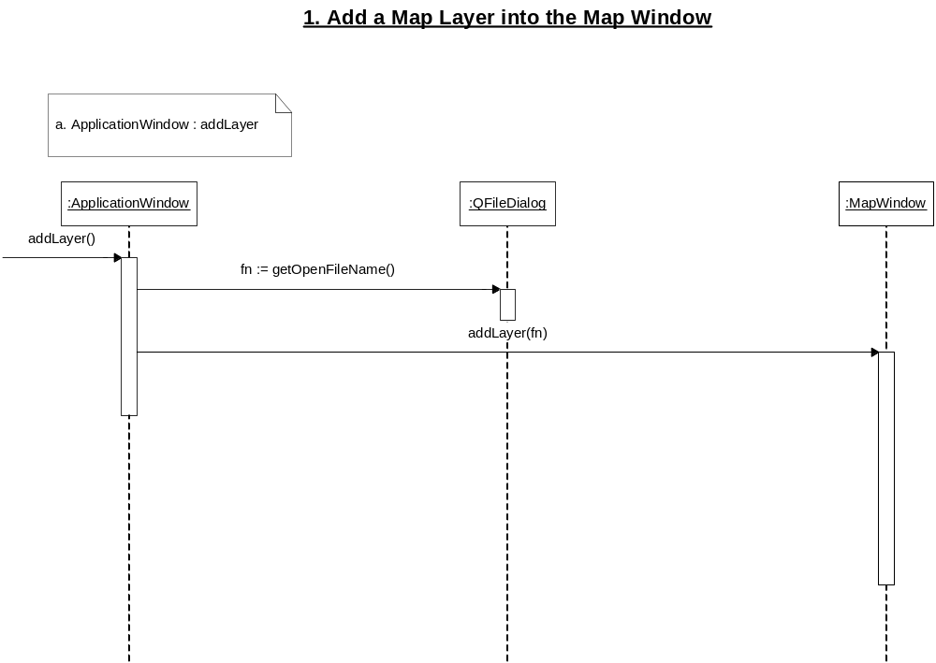
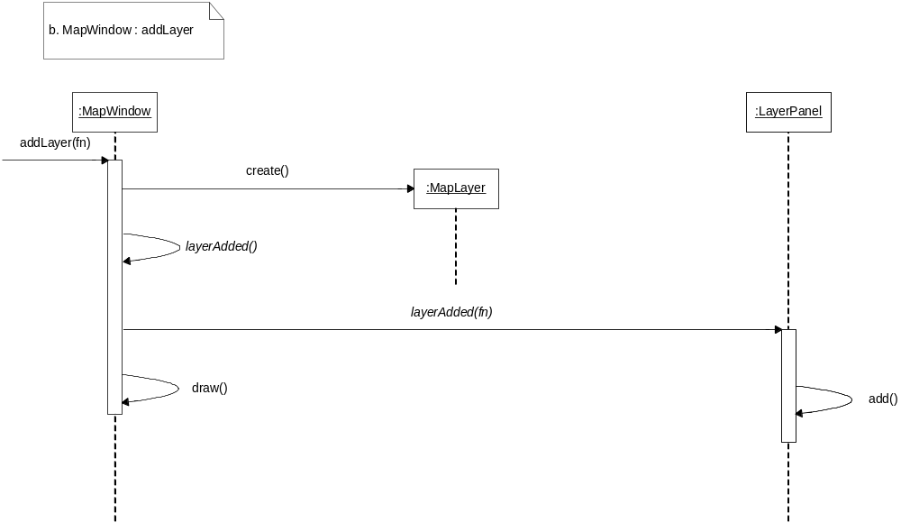

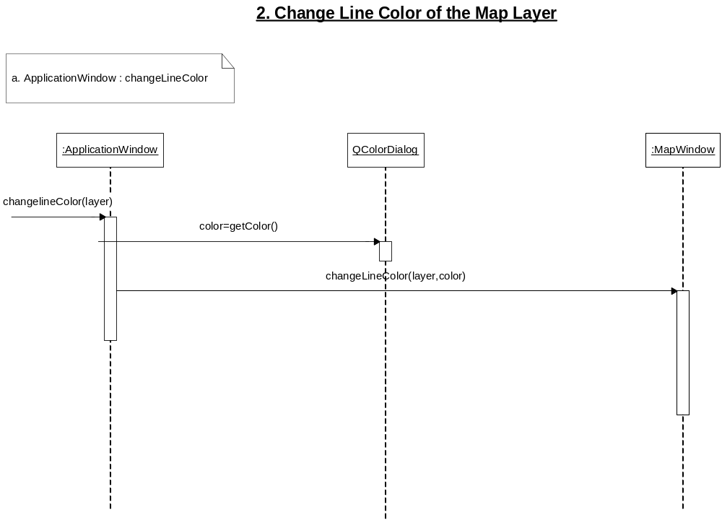
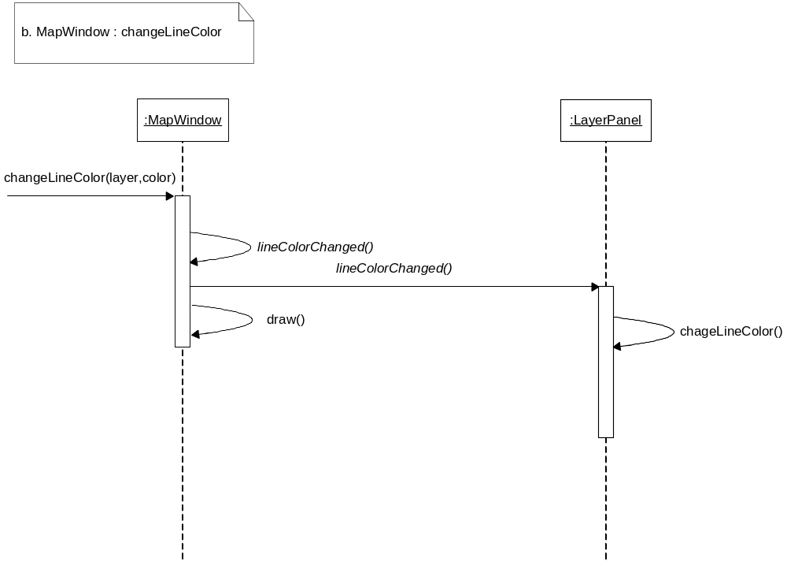
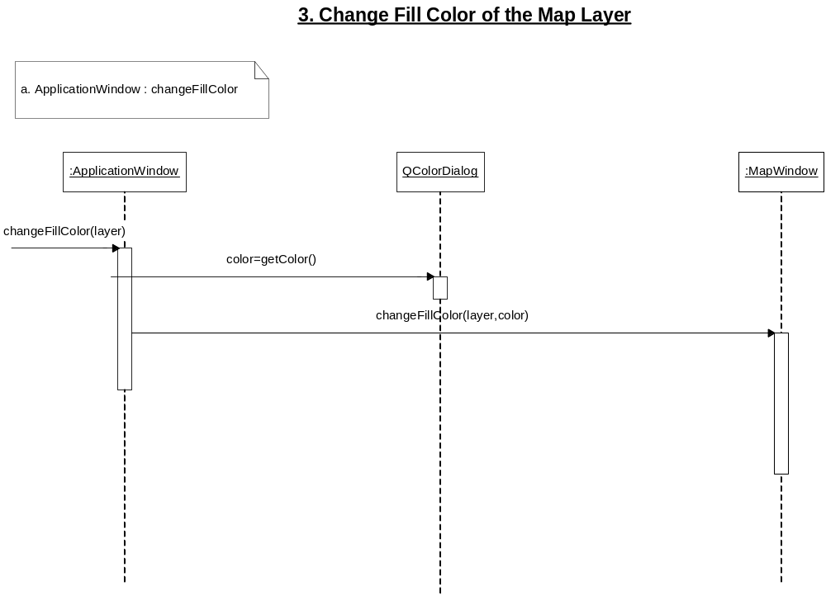
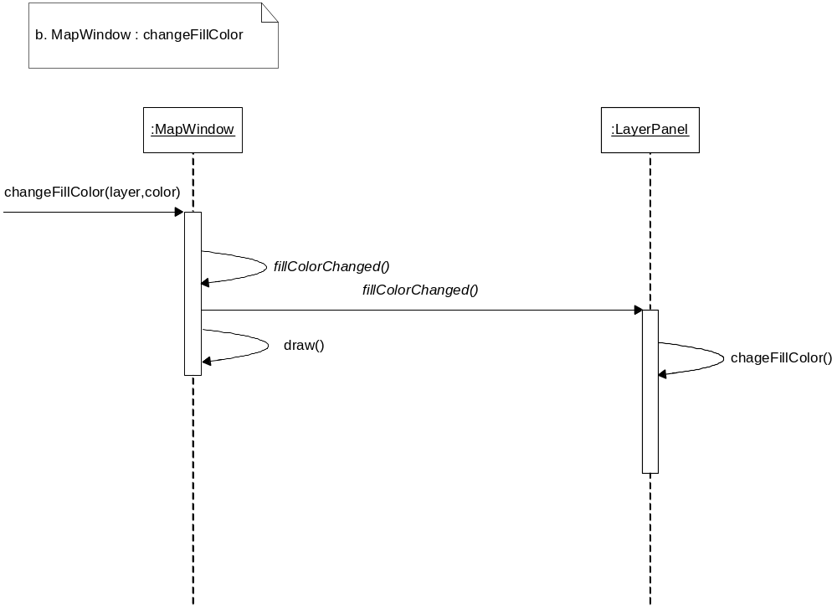
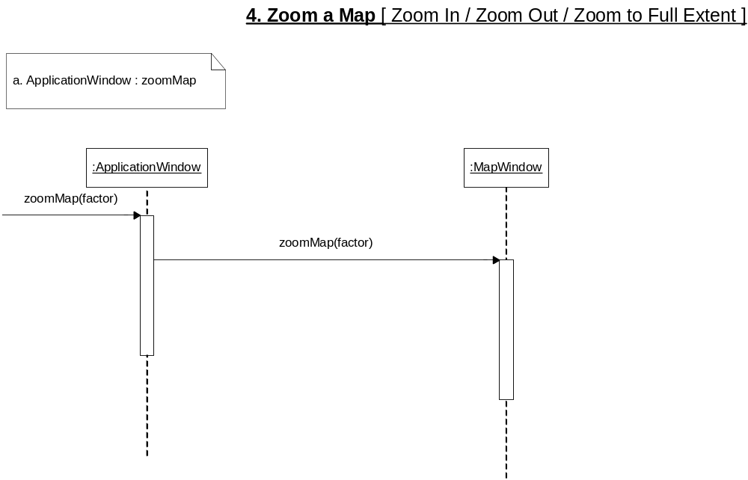
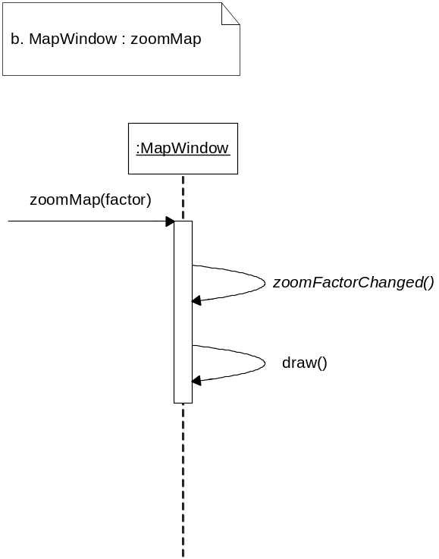

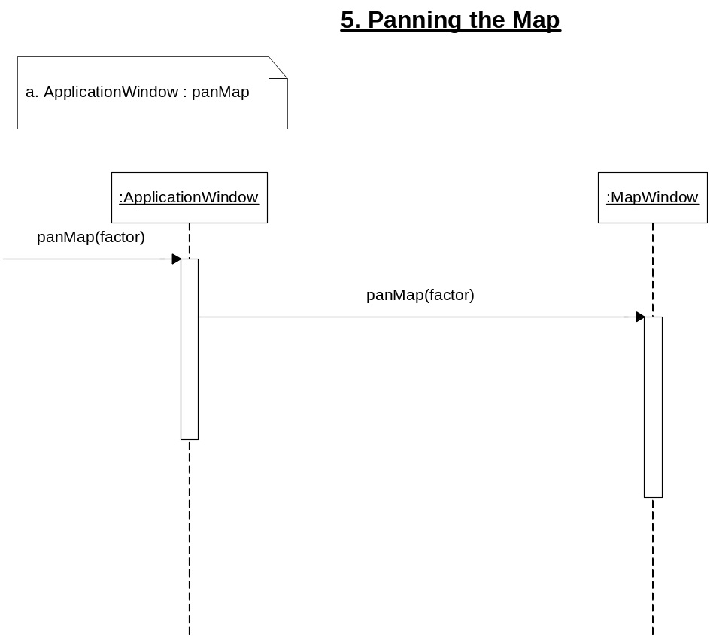
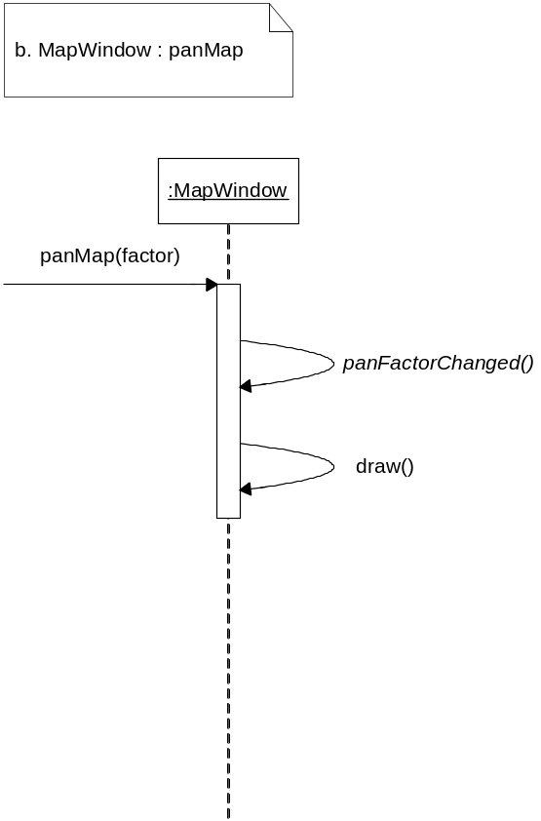
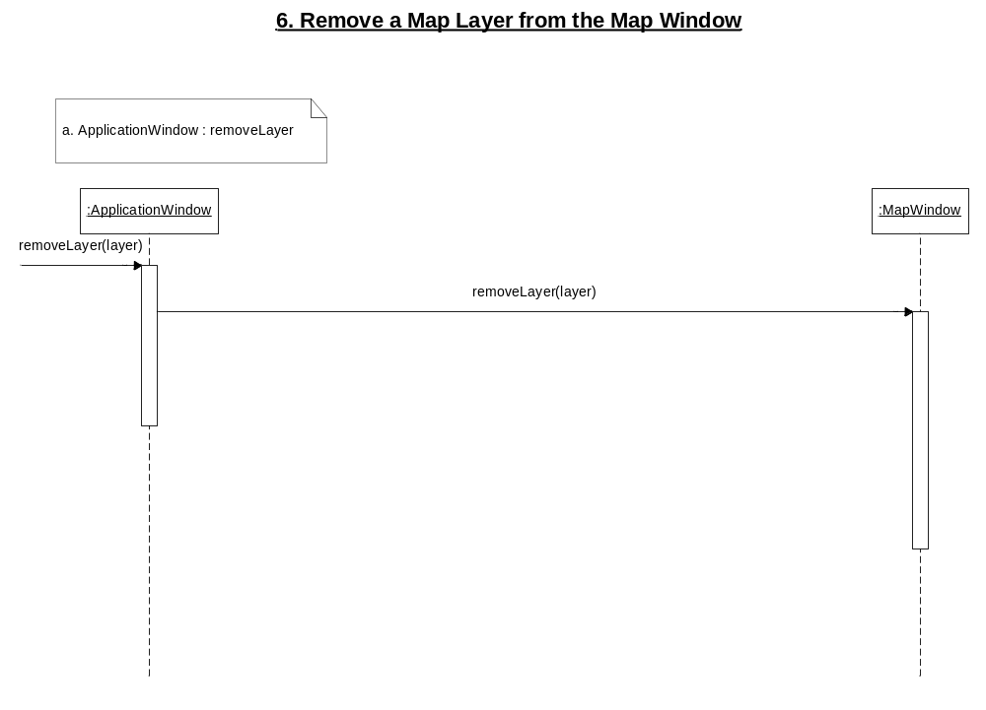
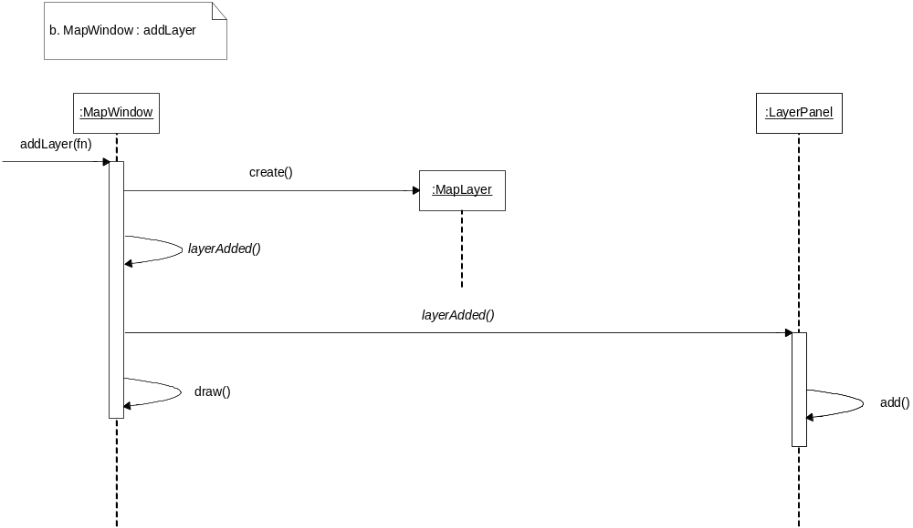

3.6 SYSTEM REQUIREMENT SPECIFICATION
This section describes about the SRS of the project.
3.6.1 Introduction
The name of our project is SmartMap, a Cosmetic Layer Designer for GIS. Our company name is Dev-iT. Our client is National Development Complex (NDC). NDC is an organization under NASCOM and the development, here, is primarily being done in GIS customizations according to the defense requirements of Pakistan.
The SmartMap application is a GIS based application and deals with a digitized map format known as Shapefiles. This format is used by ESRI (Environmental System Research Institute) for their GIS applications. The specialty of our software, that distinguishes it with others, is the introduction of Cosmetic (customized) layers and its efficiency of displaying maps.
3.6.1.1 References
The following documents define relevant material to this specification and may be referred to for additional scope and detail.
Books & Articles
- Reference 1: Programming in Qt 3
This book is essential as our project development is in Qt, a cross-platform library commonly for Microsoft, OS-2 and Unix flavors.
- Reference 2: Qt 3.3 White paper
This whitepaper gave us some important ideas about dealing with GIS based work using Qt Library.
- Reference 3: ESRI GIS. Geocoding Tutorial
This Article is taken from ESRI website and we got help in understanding how to code different map projections in languages.
- Reference 4: ESRI GIS. Modeling our World
This Article is taken from ESRI website and is a fantastic article about understanding the display of maps on screens.
- Reference 5: ESRI GIS. Understanding Map Projections
This Article is taken from ESRI website and we got help in understanding different map projections.
- Reference 6: ESRI ArcGIS Complete Manual
This is a software manual of ESRI ArcGIS software. We got information about the operations applied by ESRI on geo-referenced maps.
- Reference 7: ESRI Using ArcExplorer Java
This is a software article of ESRI ArcExplorer software. We got information about the operations applied by ESRI on geo-referenced maps.
- Reference 8: ESRI Shapefile Technical Description
This is the main article necessary to understand what a Shapefile is and its technical description.
- Reference 9: Writing Effective Use Cases
This book gave us ideas about writing the use cases in technical manners and we followed this book’s pattern of writing use cases.
Websites & Mailing Lists
- Reference 10: http://www.esri.com
This is the official website of ESRI (Environmental System Research Institute). We got a lot of information from this website, as we are following their standard file format.

- Reference 11: http://www.trolltech.com
This is the official website of Qt Library Providers. Our project development is in Qt, which is a cross-platform library commonly for Microsoft, OS-2 and Unix flavors.
- Reference 12: http://www.geocommunity.com
We use this website as for information gathering about the layouts of maps and about their projections onto the computer screen.
- Reference 13: http://www.mapinfo.com
This is the official website of MapInfo. MapInfo is also a GIS-based that basically uses other file standard but provides support for Shapefile format that is a standard by ESRI.
- Reference 14: http://groups.yahoo.com/group/esri_gis
This is a yahoo group founded by people who are interest, and doing work, in GIS-based software. We got this group very informative for us regarding SmartMap project.
3.6.1.2 Document Status
Version | Description | Status
Draft | Initial draft created for distribution and review comments. | ✓  16-06-2004
Preliminary | Second draft incorporating initial review comments, distributed for final review | ✓  19-06-2004
Final | First complete draft | ✓  02-07-2004
3.6.1.3 Document Versioning
Version No. | Release Date | Modifications
0.1 | June 16, 2004 | First Draft
0.2 | July 02, 2004 | - Addition of introduction to all references  - Change in the introduction paragraph  - Addition of UI and use cases

3.6.2 SmartMap – Overall Description
This chapter provides a detailed overview of the SmartMap, the theme of this Software Requirement Specification.
3.6.2.1 Product Perspective
Currently, our client organization, National Development Complex, is using MapInfo Professional and ESRI ArcView software, which are off the Shelf products. These software do not support adding some new layers or editing a layer, so called customization. The Map displaying mechanisms of these software is displaying the whole map at every zoom or pan operation, which makes their displaying operation slower.
3.6.2.2 User Types and Characteristics
This section also describes various characteristics of users.
User Type: Spatial Analyst
- The person who is specialized in geographical information systems.
- He needs to gather information from displayed maps in the software and these of his needs are specific to his organization.
As our client firm is working on Geographical Information Systems, so most of their high level officials and analysts are primarily Spatial Analyst for which they have been properly trained. Our target user in the firm is also the Spatial Analysts, because they are the people who need to make analysis on our SmartMap software.
3.6.2.3 Operating Environment
The SmartMap project is not a LAN based software but a stand-alone application. There is no special operating requirement, but obviously we must consider for best operating environment. For best results, Sgi Workstation is the best because Sgi Corporation designs the systems for graphical development and these systems are considered for optimum results in our client organization NDC also.
Maximum simultaneous numbers of instances for the single client applications are given in the table below:
User Interface | Application Name
No of Instances | 1

The SmartMap Software can be installed on other hardware and software platforms also. This software can be installed on Pentium III or Pentium IV also provided that there is sufficient RAM. As far as Operating System is concerned, SmartMap can run on Microsoft platforms and also on Linux Software. This is the beauty of the language Library Qt that the software can be compiled on Linux, Windows and OS-2 operating systems.
Mostly, our client has Windows 2000 Professional as the operating Systems on Pentium IV machines. So, this environment can be used for running SmartMap application. The SmartMap application will run on suitable high performance machine Sgi Workstation running IRIX Operating System environment.
3.6.2.4 Design and Implementation
The SmartMap project will be deployed in a mission critical environment requiring a fail-safe operation with an end-to-end task completion. This puts a very stringent quality requirement on the design and implementation standard. Similarly the testing of the system will therefore be of higher level. In addition to final testing of the finished SmartMap product, the design and implementation will be duly scrutinized for any shortcomings and flaws according to documented review process.
Design
The design of the SmartMap application, especially the UML Diagrams are prepared in Microsoft Visio.
System Architecture
The SmartMap application will be based on single platform architecture and there is no use of database in this application. Just we need a valid Shapefile as an input for the application. The installation of the SmartMap software on multiple machines required the installation script to be run on all machines independently.
Error Handling
The SmartMap application will be deployed in a mission critical environment. Therefore, no exception handling is used because exception handling makes the process very slow. To cope with this, all error handling is done in the traditional C++ style and every error is properly reported to the user and the software recovers gracefully.
Front-end
Requirement for the Front-end is Qt Library. All the coding has been done using a simple text editor; no GUI designer has been used to avoid extra-unwanted things in the code.
Business Logic
The business logic of SmartMap project is all in shapefile on which the project is based and the format of a shapefile is created by ESRI. The technical description of shapefile is present in section 1.2.4.

3.6.3 Functional Specifications
This chapter describes Skeletal Application and Use cases.
3.6.3.1 Skeletal application
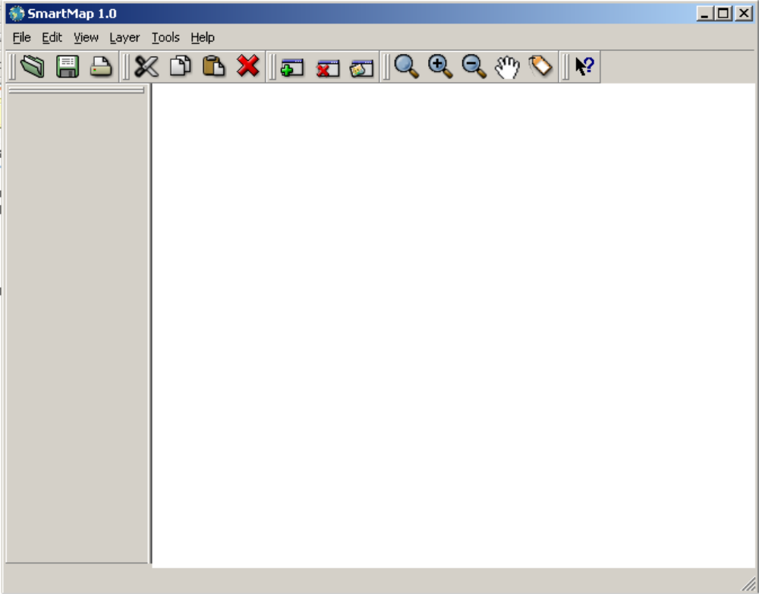
Description of the User Interface
This section describes the details of all the User interfaces of the SmartMap Software.
Title Bar
This section contains the name of the software application that is SmartMap and the name of the opened/active project if any.
Menu Bar
This section describes the referential Usecase for the detailed description of the Menu options.
- File
  - Open Project
Reference Use Case UC 14 –Open a Project
  - Save Project
Reference Use Case UC 13 – Save a Project
  - Save As
Reference Use Case UC 21 – Save As a Project
  - Close Project
Reference Use Case UC 15 –Close a Project
  - Print Image
Reference Use Case UC 20 –Print a Project
  - Exit
Reference Use Case UC 2 – Close the Application
- Edit
  - Cut
Reference Use Case UC 24 –Cut an Object from the Cosmetic Layer
  - Copy
Reference Use Case UC 25 – Copy an Object from the Cosmetic Layer

  - Paste
Reference Use Case UC 26 – Paste an Object into a Cosmetic Layer
  - Delete
Reference Use Case UC 19 – Delete an object from Cosmetic layer
  - Copy Map Image to File
Reference Use Case UC 23 – Copy Map Layer to an Image File
  - Preferences
Reference Use Case UC 4 – Changing the Fill color of a layer
Reference Use Case UC 5 –Changing the Line color of a layer
- Layer
  - Add Layer
Reference Use Case UC 3 – Add a map layer into the Map Window
  - Remove Layer
Reference Use Case UC 10 – Remove a layer
  - New Cosmetic Layer
Reference Use Case UC 16 – Add a new Cosmetic layer in Map Window

- Tools
  - Zoom Full Extent
Reference Use Case UC 6 –Zoom the Map to Full Extent
  - Zoom In
Reference Use Case UC 7 –Zoom In the Map
  - Zoom Out
Reference Use Case UC 8 –Zoom Out the Map
  - Pan
Reference Use Case UC 9 – Panning the Map
  - Identify
Reference Use Case UC 22 – Identify a location on Map Layer
Toolbar
This section describes the referential Usecases for the detailed description of the Tools in the Toolbar of SmartMap software.
  - Reference Use Case UC 14 –Open a Project
  - Reference Use Case UC 13 – Save a Project
  - Reference Use Case UC 20 –Print a Project
  - Reference Use Case UC 24 – Cut an Object from the Cosmetic Layer
  - Reference Use Case UC 25 – Copy an Object from the Cosmetic Layer
  - Reference Use Case UC 26 – Paste an Object into a Cosmetic Layer
  - Reference Use Case UC 19 – Delete an object from Cosmetic layer
  - Reference Use Case UC 3 – Add a map layer into the Map Window
  - Reference Use Case UC 10 – Remove a layer
  - Reference Use Case UC 16 – Add a new Cosmetic layer in
Map Window
  - Reference Use Case UC 6 –Zoom the Map to Full Extent
  - Reference Use Case UC 7 –Zoom In the Map
  - Reference Use Case UC 8 –Zoom Out the Map
  - Reference Use Case UC 9 – Panning the Map
  - Reference Use Case UC 22 – Identify a location on Map Layer
Workspace
  - Legend Window
This is the section displayed in the left division of the Main Application window. The opened Shapefiles’ names are displayed here with checkboxes to check/uncheck them to display/hide a layer that is being displayed in the Map Window.
  - Map Window
This is the section displayed in the left division of the Main Application window. The Shapefile is opened and displayed in the map window and after it is displayed here, we call it a Layer or a Map Layers.
Status Bar
This section is used to display the Latitude and Longitude of a position in the map, at which the mouse pointer is currently placed. This thing also contributes to the Geo-Referencing mechanism of SmartMap Application.
3.6.3.2 Use Cases
Use cases are described in section 3.5.1.
3.6.4 Nonfunctional Requirements
3.6.4.1 Security Requirements
The Security requirement for the use of software is that only the authorized Spatial Analyst can use the software. Our client organization maintains this security themselves, by providing the software installations only to the workstations of authorized Spatial Analysts. The software CDs are kept in secure place and all the security is the responsibility of our client organization.
3.6.4.2 Software Quality Attributes
All our software coding is according to SW-CMM level 2.

Chapter 4
DESIGN

4.1 CLASS DIAGRAM
These class diagrams show the inheritance of multiple classes in the proposed system that are extracted during Design phase of the project.
Class Diagram of Application which are inherited from the Qt Library’s Classes

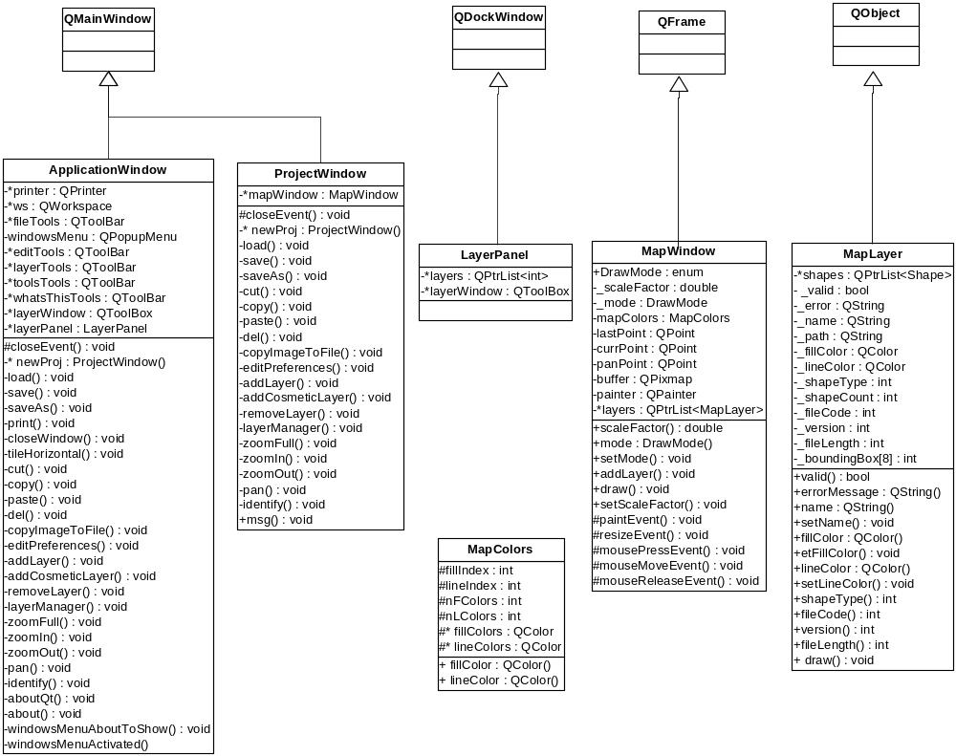

Class Diagram of multiple shape types inherited from a class Shape

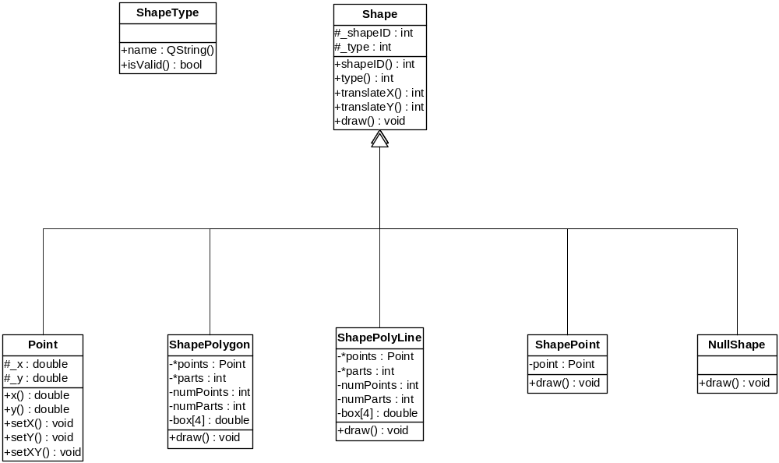

CLASS ASSOCIATION DIAGRAM
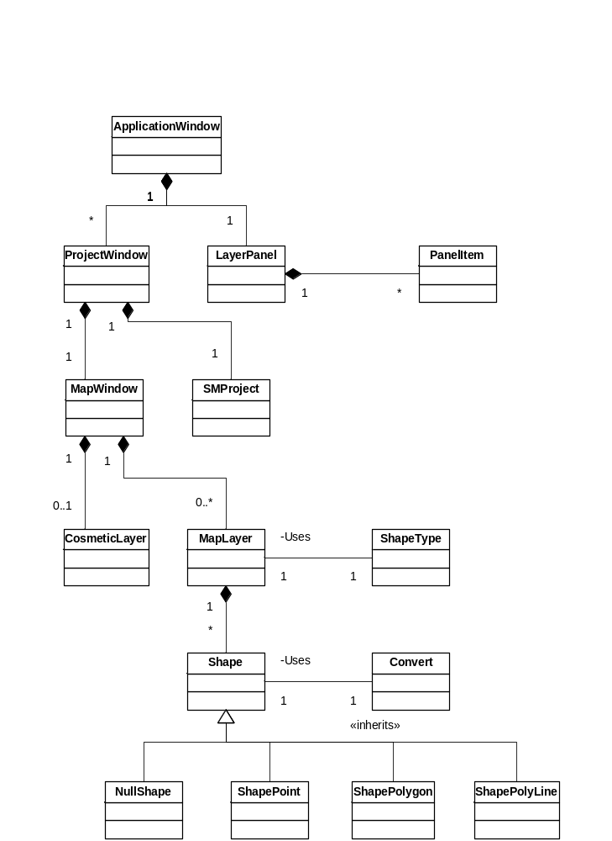

4.3 INTERACTION DIAGRAM
Interaction diagrams are shown in section 3.5.2 in detail.
Chapter 5
IMPLEMENTATION AND TESTING

5.1 IMPLEMENTATION DESCRIPTION
Our project’s functionality is not divided into different functional layers. This is a standalone application and does not require any client-server architecture. Further implementation description of the application is as follows:
- Map representation to the spatial analyst is by the Graphical user interface.
- All Graphical User Interfaces are designed using Qt Library.
- Other core functionality of the application is divided into different classes.
- All the classes used in the application are shown in class diagram in section 4.1.
- During the implementation phase, no DLLs were deployed.

5.2 TESTING
System testing is an essential step for the development of a reliable and error-free system. Our application had been passed through testing while executing the program with the explicit intension of finding errors i.e., making the program fail and test cases are devised with the purpose in mind. A test case is a set of data items that the system processes as normal input. A successful test is the one does find an error. On having successful test cases, we resolved the errors and bugs from the system successfully.
5.3 TESTING STRATEGIES
The basic strategies that were used for testing were following
- Black Box testing
- White Box testing
- Unit Testing
- Regression Testing
- System Testing
- Acceptance Testing
Each of the strategy are discussed as following
5.3.1 Black Box Testing
In Black Box testing only the functionality of the software was tested without any regard to the code written. If the functionality, which was expected from the application, is provided then black box testing is completed.
5.3.2 White Box Testing
In White Box testing internal code written in all modules was tested and it was checked that the code written is efficient in utilizing various resources of the system like memory or the utilizing of input output.
    - Unit Testing
In unit testing, we checked that all the individual modules were working properly. Before integration of all the modules, unit testing is essential because it gives a confidence that all the modules individually are working fine and ready to be integrated with the other ones.
    - Regression Testing
In Regression testing, the software was tested against the boundary conditions. Various input shapefiles were tested against abnormal conditions and it was tested that the software does not behave abnormally at any time.

5.3.5 System Testing
When all the units were working properly and unit testing was performed then came the time for system testing where we checked all the integrated modules as a whole and looked for possible discrepancies, which could have arisen after the integration.
5.3.6 Acceptance Testing
In acceptance testing the software was checked for completeness that it is ready. Normally the quality assurance department performs the acceptance testing that the software is ready and can be exported.
Chapter 6
RESULTS AND DISCUSSIONS

6.1 ACHIEVEMENTS
We feel satisfied after the development and implementation of our final project successfully. Before developing through this project although we had a good theoretical knowledge of software engineering, being students of computer science, but it is far away from theory to develop a real life system that completely fulfill the user requirements. We had a very good interaction with our internal supervisor Mr. Tanveer Ahmed and also with our external supervisors Mr. Asif Hameed Qazi and Mr. Nasir Siddique, they helped us a lot to develop the system well in time.
During the development of the project we have achieved the following benefits.
- Project management and scheduling
- How to interact with the user
- System analysis and data collection
- A good knowledge of system designing and modeling
- Latest tools and technologies
- Testing strategies
- User documentation
During the modeling phase we learnt
- Rational Rose for UML.
During testing and implementation finding a bug and its fixture was totally new and healthy experience. One of the very important aspects of the project was how to document our project properly.
We have learnt a very powerful tool i.e. Qt, a cross platform C++ Library which will help us a long way as we will be starting our careers as IT professional.
6.2 LIMITATIONS
The project is developed keeping in view the research oriented requirement of a final master project. So it may lack some elegance or sophistication but we are very much satisfied that we have worked in a highly versatile environment and we have taken the right steps towards the right direction in terms of where the technology is going nowadays.
SUMMARY

This project has been assigned to us by NDC (National Development Complex). Currently they are working on several GIS (Graphical Information System) based projects, our project is a module of one of their projects.

Cosmetic Layer Designer for GIS is a software application that will enable the user to draw multiple layers on the digitized map, which are geo-referenced. A layer may represent a chain of hospitals or multiple locations of an office across the globe or in a single country. A user will be able to draw layer of his own choice and on demand, he can place that custom layer back onto the map to see his provided information. In this way, at a time a user can place all the layers on to a single map to get as per his requirements (for example, a user can place a layer of hospitals in Pakistan as well as a layer containing the public exchange locations across the country).
The main operations that the software will perform are:

- Read a digitized map.
- Display it in efficient manner. By efficient manner, we mean displaying the map using multi-threaded process.
- Implement the zooming, panning and projection operations on the map.
- Enable the user to turn ON or OFF the visibility of a particular layer onto the map.
- Allow the user to create a cosmetic layer, which can enables the user to draw shapes.

